Team Jack London

Team Members

- Depressor – Иван Тончев
- Havaliova – Илвие Хавальова
- MartinHristov – Мартин Христов
- sscar.tissue – Тихомир Дамянов
- vanina_nenova – Ванина Ненова

Project Explanation
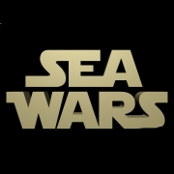

In our game the player is the captain of a ship, which fights with other ships. Each of them has a health status and it is equipped with walls and cannons displayed on two rows. The battle is in turns – this is when the cannons of one of the ships shoot at the walls of the other. If the wall is destroyed, the damage inflicts the health status of the ship. Before every turn the captain can use one of his skills and after each battle the player can visit a mechanic or an engineer to fix or improve the ship’s equipment.

GIT REPOSITORY

https://github.com/ms-nenova/JackLondonTeam

Class Diagram:
